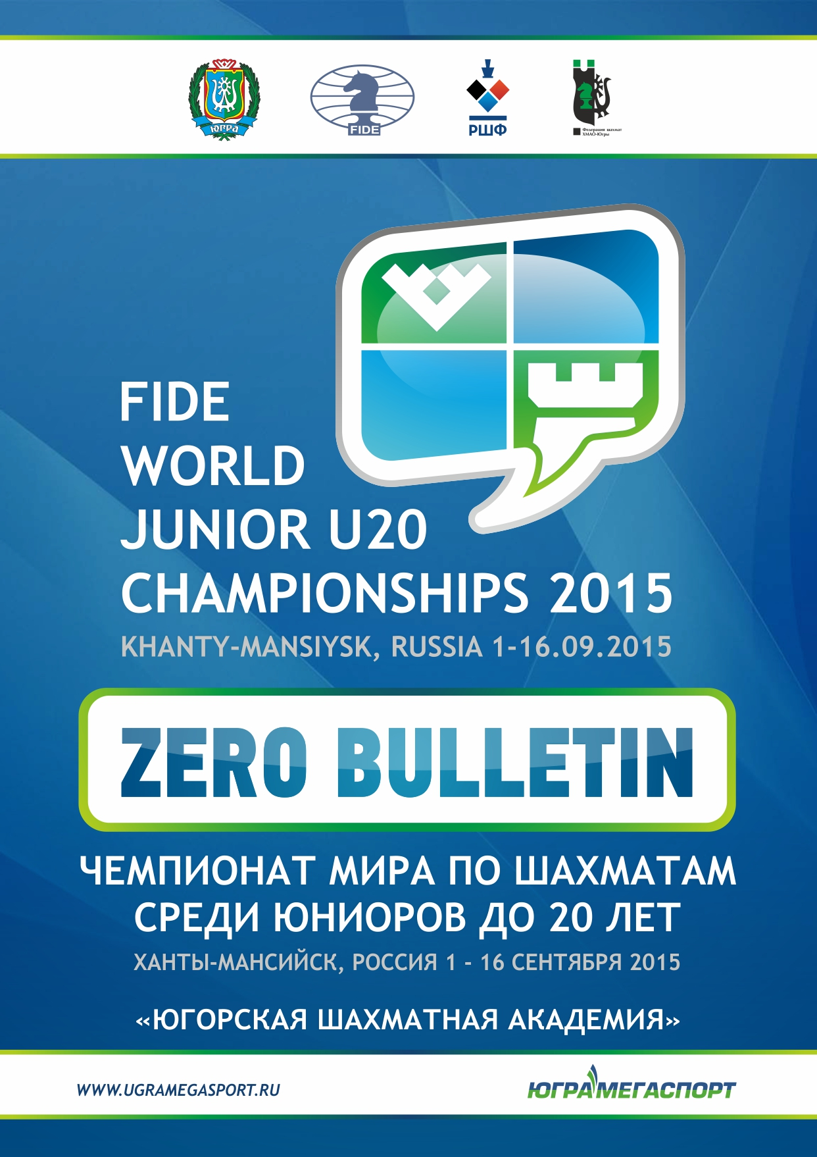
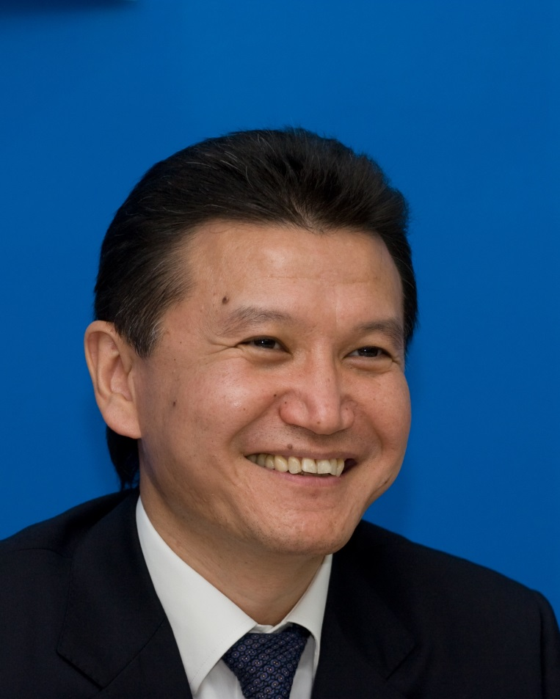
Dear participants and guests of the FIDE World Junior Under-20 Championships 2015 in Khanty-Mansiysk!

I greet you with all of my heart in one of the chess cities of Russia and the whole planet, which hosted the biggest international chess tournaments many times! In different years the World Candidates Tournament, the FIDE Women’s and Men’s World Rapid and Blitz Championships, Women’s World Championship and 3 World Chess Cups took place here.
Value of the FIDE World Junior Championships 2015 is equal to all mentioned prestigious Tournaments, because this very Championship will determine chess elite of the next generation, and the face of future chess will come to light.
I thank with all my heart the authority of Khanty-Mansiysk autonomous okrug – Ugra, Russian Chess Federation, Chess Federation of Khanty-Mansiysk autonomous okrug – Ugra, AI “UgraMegaSport” and our sponsors for every possible support of the Championship and for a great organizational work.
Gens una sumus! We are one family!

Kirsan Ilyumzhinov
FIDE President

Information about Russia
Population
146 267 288 of residents (1st of January 2015 estimate)
Language
Russian is the official language throughout the country; there are 37 official languages in republics of Russian Federation and more than 15 languages with official standing.
Religion
Christianity, Islam, Buddhism, Judaism.
Climate
There are 2basic seasons almost all over the territory of Russian Federation – winter and summer; spring and autumn are usually brief periods of changing from high temperatures to low. The coldest month is January, the warmest is usually July. In winter temperature gets colder from south to north and from west to east. Summers can be quite hot, even in Siberia.

General Information about Khanty-Mansiysk autonomous okrug-Ugra

The symbols of Khanty-Mansiysk autonomous okrug-Ugra are the emblem and the flag.
Khanty-Mansiysk autonomous okrug (historical name of the okrug is Ugra) was established on the 10th of December 1930 as Ostyako-Vogulskiynational okrug with a center in the village Samarovo.

Total number of municipal units is 105.
Administrative center of the okrug is Khanty-Mansiysk.
Square – 534.8 thousand km²
Resident Population (1 Jan. 2015) – 1 612 076 people.
Khanty-Mansiysk autonomous okrug consists of 13 city districts, 9 districts, 26 urban settlements, 57 rural settlements.

The okrug is the main oil-and-gas bearing region in Russia and one of the biggest oil-producing regions in the world. It is considered to be a region-donor of Russia and takes the lead in several economic indicators: output of oil, output of electrical power, industrial output, natural gas production, investments volume in the capital stock, return of duties in the budget system.
The okrug is situated in the middle part of Russia. It occupies the central part of West Siberian plain.

Climate is strongly continental. Average temperature in January is from -18º till -24º C,
Average temperature in July is from +15.7ºtill+18.4º C.
Information about the okrug – www.admhmao.ru.

Information about the town

Time difference between Moscow and Khanty-Mansiysk: 2 hours
Geographic latitude: 61°00’
Geographic longitude: 69°01’

Khanty-Mansiysk, a capital of Khanty-Mansiysk autonomous okrug, is situated in the Western Siberia on the river Irtysh (a port), 15 km. away from its confluence with the river Ob, 264 km to the west from the railway station «Pyt’-Yah», 1076 km. to the north-east of Tyumen, 2759 km. to the north-east of Moscow on seven hills covered with coniferous woods. This nice and comfortable town slightly reminds Scandinavian resort.
Khanty-Mansiysk is a town with a unique, even for 21st century, social infrastructure: according to the decision of the authorities all industrial productions were moved out of the town. In and around the town taiga wood was cleared and put to an appropriate ecological state. And in reality it became a national park of Siberia. Here a rare combination of comfortable urbanism and ecological purity was created. Taiga that spreads for hundred kilometers to all parts around the town provides the existence of such uniqueness.
Nowadays Khanty-Mansiysk develops not only as a center of the oil region but it becomesa center of business activity, sport, and national culture. There is an Arts Center for Talented Children of North which is one of the best in Russia, the Alexander Filipenko Winter Sport Center equipped with the modern facilities, airportwith air strips for all types of aircrafts, office and business centers, House of Peoples’ Friendship, Temple Complex for 1000people with Samarovo high school for 60 people. Uniqueness of the modern architecture in combination with nature attracts hundreds of tourists and guests to this town annually.
Information about the town - www.admhmansy.ru

Meteorologic Statistics (Khanty-Mansiysk)

Month | September  2009 | September  2010 | September  2011 | September  2012 | September  2013 | September  2014
Absolute Max | +30 | +20 | +25 | +23 | +17 | +18
Average Temperature | +20 | +10 | +16 | +14 | +12 | +8
Absolute Min | +11 | +2 | +7 | +2 | +2 | 0
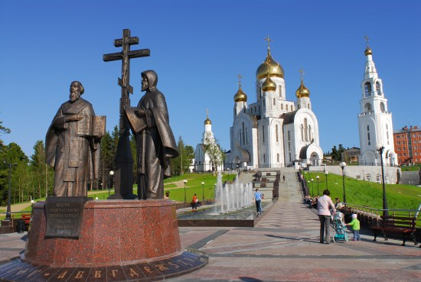

Program of the FIDE World Junior Under-20 Championships 2015

Date |  | Time | Event | Venue
31.08.2015 | Mon |  | Arrival
01.09.2015 | Tu |  | Arrival
 |  | 16:00 | Player’s meeting | CLC «October»
 |  | 17:00 | Opening Ceremony
02.09.2015 | We | 15:00 | Round 1 | «Ugra Chess Academy»
03.09.2015 | Th | 15:00 | Round 2
04.09.2015 | Fr | 15:00 | Round 3
05.09.2015 | Sa | 15:00 | Round 4
06.09.2015 | Su | 15:00 | Round 5
07.09.2015 | Mon | 15:00 | Round 6
08.09.2015 | Tu | 15:00 | Round 7
09.09.2015 | We |  | Day off
10.09.2015 | Th | 15:00 | Round 8
11.09.2015 | Fr | 15:00 | Round 9
12.09.2015 | Sa | 15:00 | Round 10
13.09.2015 | Su | 15:00 | Round 11
14.09.2015 | Mon | 1:00 | Round 12
15.09.2015 | Tu | 11:00 | Round 13
 |  | 19 :00 | Closing Ceremony | CLC «October»
16.09.2015 | Th |  | Departure

Officials of the FIDE World Junior Under-20 Championships 2015

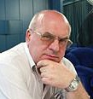  Chief Arbiter  Mikhail Kryukov  (RUS)  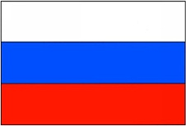 | 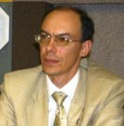  Deputy Chief Arbiter (open)  Stanislav Yanushevsky  (RUS) | 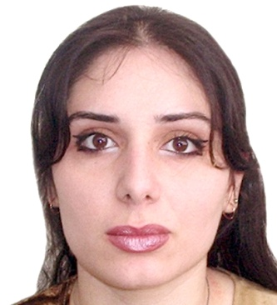  Deputy Chief Arbiter (girls)  Marika Japaridze  (GEO)  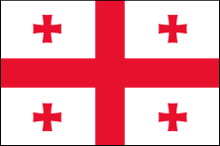

Appeals Committee
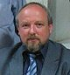  Chairman of Appeals Committee  Vladimir Ginzburg (BLR)  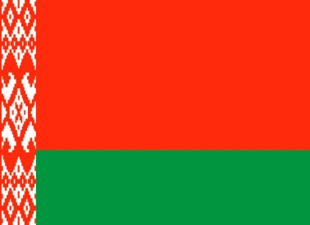 | 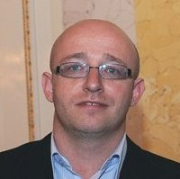  Member of Appeals Committee  Petr Pisk(CZE)  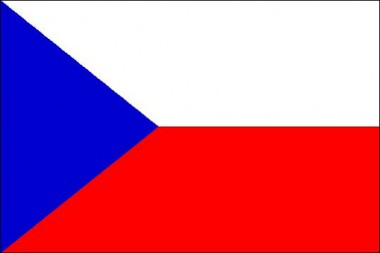 | 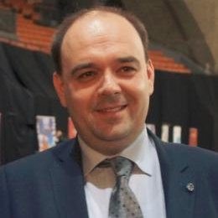  Member of Appeals Committee  Adam Dzwonkowski (POL)

Arbiters
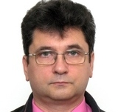  Arbiter RCF  Vladimir Staratorzhskiy (RUS) | 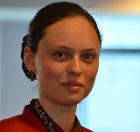  Arbiter RCF  Evgeniya Magdalinskaya (RUS) |  | 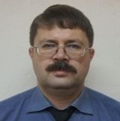  Arbiter RCF  Vladimir Makhnev (RUS)
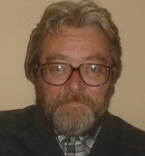  FIDE Arbiter  Branislav Suhartovic (SRB)  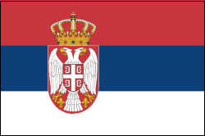 |  | 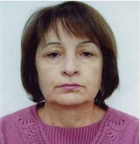  FIDE Arbiter  Juleta Nahatakyan (ARM)  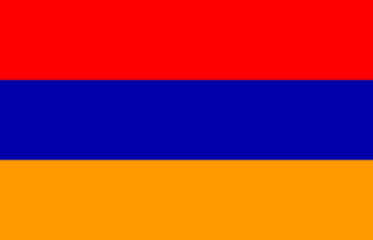

Ugra Arbiters
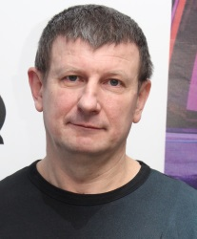  Allexander Korneevets | 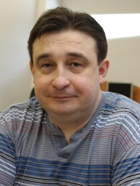  Roman Lavretskiy | 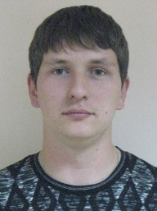  Radmil Akhmetov
Participating countries

1. | 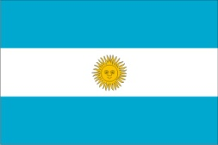  ARG | 2. | 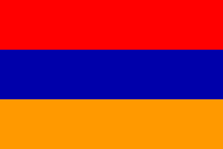  ARM | 3. | AUT | 4. | 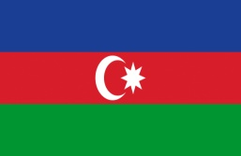  AZE
5. | 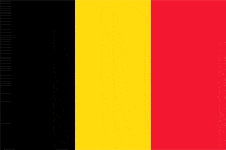  BEL | 6. | 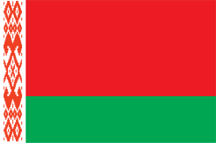  BLR | 7. | 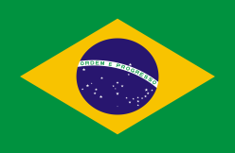  BRA | 8. | 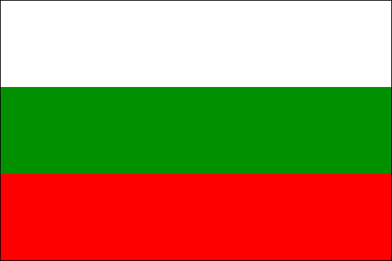  BUL
9. | 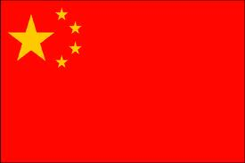  CHN | 10. | 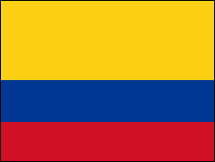  COL | 11. | 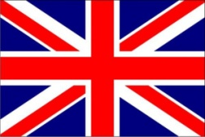  ENG | 12. | 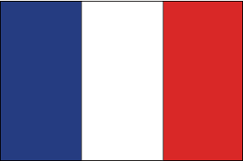  FRA
13. | 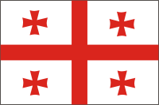  GEO | 14. | 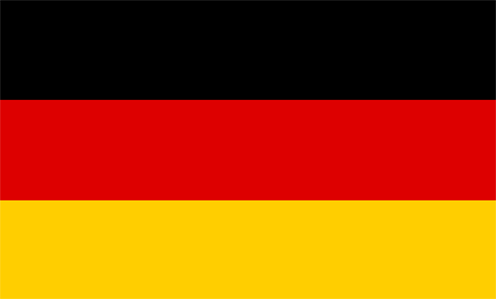  GER | 15. | 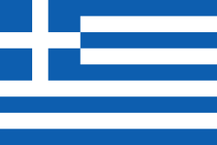  GRE | 16. | 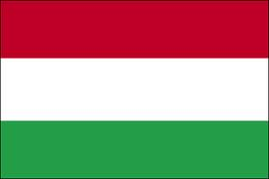  HUN
17. | 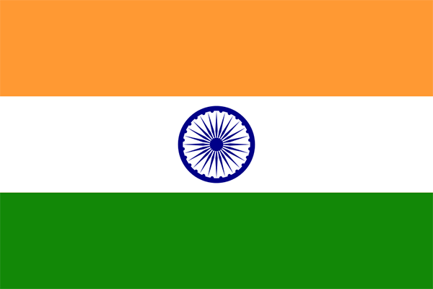  IND | 18. | INA | 19. | 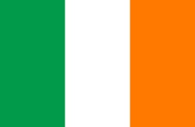  IRE | 20. | 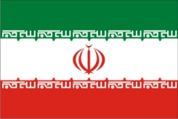  IRI
21. | 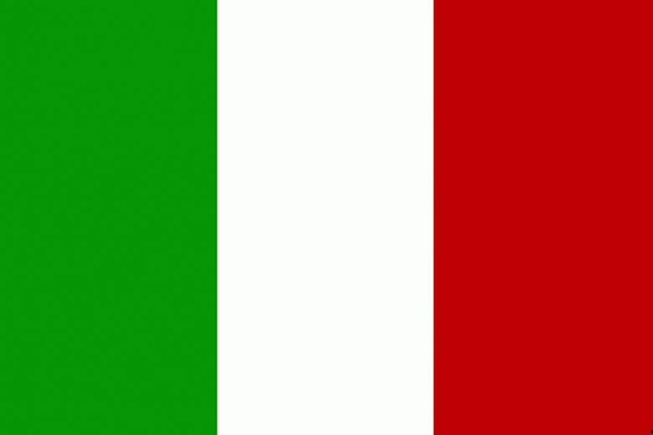  ITA | 22. | 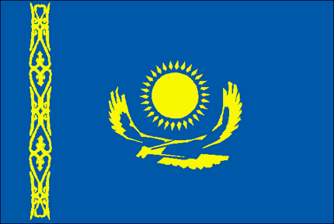  KAZ | 23. | 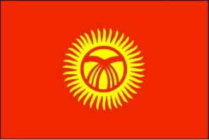  KGZ | 24. | 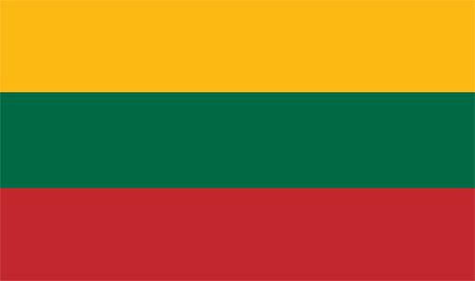  LTU
25. | 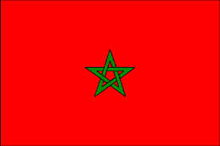  MAR | 26. | 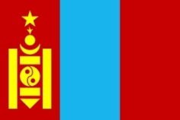  MNG | 27. | 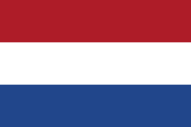  NED | 28. | 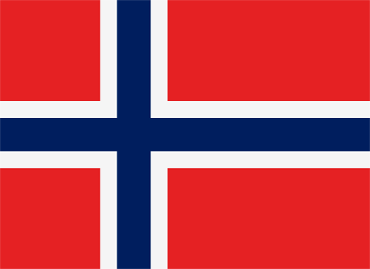  NOR
29. | 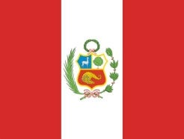  PER | 30. | POL | 31. | 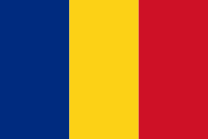  ROU | 32. | 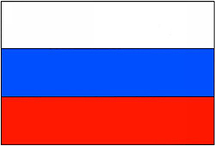  RUS
33. | 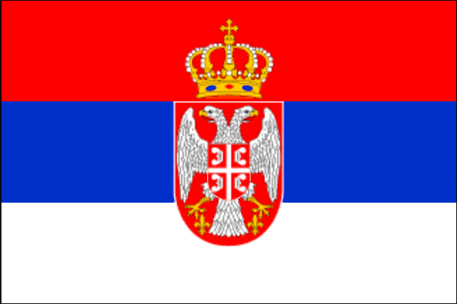  SRB | 34. | 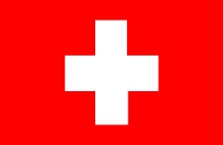  SUI | 35. | 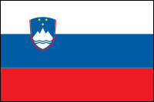  SVN | 36. | 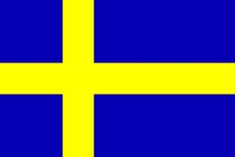  SWE
37. | 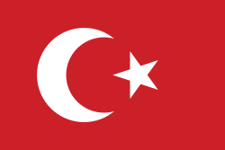  TUR | 38. | 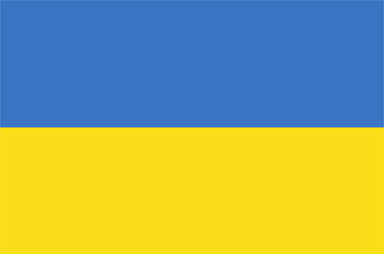  UKR | 39. | 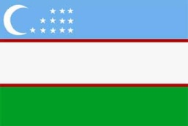  UZB | 40. | 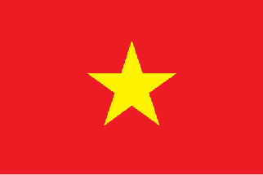  VIE

Participants of the FIDE World Junior Under-20 Championships 2015 in Khanty-Mansiysk
Country | № | Open |  | Country | № | Girls
ARG | 1 | Pichot Alan |  | ARM | 1 | Gaboyan Susanna
ARM | 2 | Grigoryan Karen |  | AZE | 2 | Amrayeva Aytan
AUT | 3 | Menezes Christoph |  |  | 3 | Ibrahimova Sabina
AZE | 4 | Abasov Nijat |  |  | 4 | Fataliyeva Ulviyya
 | 5 | Bajarani Ulvi |  |  | 5 | Mammadzada Gunay
 | 6 | Iskandarov Misratdin |  | BEL | 6 | Barbier Astrid
BEL | 7 | Fontaine Quentin |  | BLR | 7 | Kusenkova Natallia
 | 8 | Lootens Matthias |  |  | 8 | Ziaziulkina Nastassia
 | 9 | Van Laeken Jonathan |  | BUL | 9 | Vasova Maria
BRA | 10 | Carneiro Vitor Roberto Castro |  | COL | 10 | Rodriguez Rueda Paula Andrea
 | 11 | Dias Matheus Nunes |  | ENG | 11 | Hoare Amelia
CHN | 12 | Bai Jinshi |  | FRA | 12 | Navrotescu Andreea-Cristiana
ENG | 13 | Kirk Ezra |  |  | 13 | Thomas Anysia
FRA | 14 | Barbot Pierre |  | GEO | 14 | Khomeriki Nino
 | 15 | Dutreuil Raphael |  | GER | 15 | Osmanodja Filiz
 | 16 | Loiseau Quentin |  | HUN | 16 | Terbe Julianna
GEO | 17 | Beradze Irakli |  | INA | 17 | Medina Warda Aulia
GER | 18 | Bluebaum Matthias |  | IND | 18 | Gajendra Babu Kannaiyan  Monnisha
GRE | 19 | Megalios Konstantinos |  |  | 19 | Bodda Pratyusha
IND | 20 | Bharathakoti Harsha |  |  | 20 | Jayakumar Saranya
 | 21 | Gagare Shardul Annasaheb |  |  | 21 | Prince Michelle Catherina
 | 22 | Ganesan Akash |  | IRI | 22 | Derakhshani Dorsa
 | 23 | Murali Karthikeyan |  | ITA | 23 | Movileanu Daniela Roxana
 | 24 | Sunilduth Lyna Narayanan |  | KAZ | 24 | Abdumalik Zhansaya
IRE | 25 | O'Mahoney Keegan |  |  | 25 | Assaubayeva Bibissara
ITA | 26 | Rambaldi Francesco |  |  | 26 | Saduakassova Dinara
KAZ | 27 | Makhnev Denis |  | KGZ | 27 | Musaeva Shakhnazi
 | 28 | Saiyn Zhanat |  | MGL | 28 | Bayarjargal Bayarmaa
 | 29 | Serikbay Chingis |  |  | 29 | Norovsambuu Badamkhand
KGZ | 30 | Isaev Chyngyz |  | PER | 30 | Paredes Bustamante Paula
 | 31 | Taalaibekov Tagir |  | POL | 31 | Wozniak Mariola
LTU | 32 | Laurusas Tomas |  | ROU | 32 | Gelip Ioana
MAR | 33 | El Fezari Mohamed Amin |  | RUS | 33 | Bivol Alina
MGL | 34 | Bilguun Sumiya |  |  | 34 | Drogovoz Irina
NED | 35 | Bok Benjamin |  |  | 35 | Drogovoz Maria
 | 36 | Van Foreest Jorden |  |  | 36 | Garifullina Leya
NOR | 37 | Tari Aryan |  |  | 37 | Ivanova Karina
PER | 38 | Cori Tello Jorge Moises |  |  | 38 | Lingur Zalina
 | 39 | Leiva Rodriguez Giuseppe |  |  | 39 | Makarenko Alexandra
POL | 40 | Duda Jan Krzysztof |  |  | 40 | Sazonova Anastasia
ROU | 41 | Bida Mihai-Eugen |  |  | 41 | Sviridova Vlada
RUS | 42 | Antipov Mikhail |  |  | 42 | Utyatskaya Irina
 | 43 | Chigaev Maksim |  | SRB | 43 | Milosevic Jovana
 | 44 | Chumak Dmitry |  | SVN | 44 | Leonardi Caterina
 | 45 | Gordievsky Dmitry |  | SWE | 45 | Bengtsson Jessica
 | 46 | Goryachkina Aleksandra |  | UKR | 46 | Buksa Nataliia
 | 47 | Korchmar Vasiliy |  | VIE | 47 | Nguyen Thi Thuy Trien
 | 48 | Popov Mikhail
 | 49 | Yuffa Daniil
SRB | 50 | Ratkovic Miloje
SUI | 51 | Georgiadis Nicolas Lukas
 | 52 | Studer Noel Oliver
 | 53 | Hasenohr Benedict
SWE | 54 | Johansson Linus
TUR | 55 | Sanal Vahap
 | 56 | Ali Marandi Cemil Can
 | 57 | Arat Ufuk Sezen
 | 58 | Ererdem Gani Eren
UKR | 59 | Bogdanov Egor
UZB | 60 | Vokhidov Shamsiddin
VIE | 61 | Tran Tuan Minh

Venue of the FIDE World Junior Under-20 Championships 2015
Ugra Chess Academy
Khanty-Mansiysk
6 Loparev St.

The FIDE World Junior Under-20 Championships 2015 will take place in a modern building of the «Ugra Chess Academy» that is situated in the downtown.

The modern energy-conservative technologies and engineering solutions were used in the process of constructing of the building, they provide the complex with the multi-functional usage and allow reducing the expenses for power consumption and conditioning of the building. The unique three-level building without sharp corners styled as a chess piece was built in the capital of Ugra during two years upon the project of the famous Dutch architect Erick Van Egeraat.

Playing hall –the games will be held in the playing hall located at the 1st floor of the Academy. The hall can be transformed and changed in size due to the innovative regulated walls and folding spectator stand. Over the last years a number of international congresses and forums took place in the hall, regional and Russian tournaments are constantly held here.

Events, that took place in the Ugra Chess Academy:
- 2010:
- General Assembly as a part of the 39th World Chess Olympiad.
- The 81st FIDE Congress.
- 2011:
- Internationall Paralympic Committee Forum as a part of IPC Biathlon and Cross-Country Skiing World Championship.
- World Chess Cup
- 2012:
- The Chess Tournament as a part of III All-Russian Summer Universiade.
- FIDE World Women’s Chess Championship
- 2013:
- The FIDE World Rapid and Blitz Championships
- 2014:
- World Candidates Tournament 2014;
- Women’s FIDE Grand Prix 2014;
- FIDE Women’s World Rapid and Blitz Championships 2014
- 2015:
- FIDE Grand Prix Series 2014-2015.

Besides of these events a lot of regional, all-Russian and international tournaments are held in the Ugra Chess Academy in which players of different age category took part.

Besides the tournament hall the Ugra Chess Academy consists of classrooms for children who are keen on chess, computer classrooms for holding the internet-tournaments, a cozy café and a hall decorated with pieces of art regarding chess.

FIDE office, Chief Arbiter’s and jury rooms, technical room for online game transmission are arranged in close vicinity to the playing hall on the first floor.

Online transmission of the game, ground floor – there will be a match transmission room where spectators will have the opportunity to follow the games.

Game analysis room, ground floor – computer classroom will be used by the players as a game analysis room with access to the Internet.

The press-center with the hall for press-conferences and OC Office will be on the ground floor.

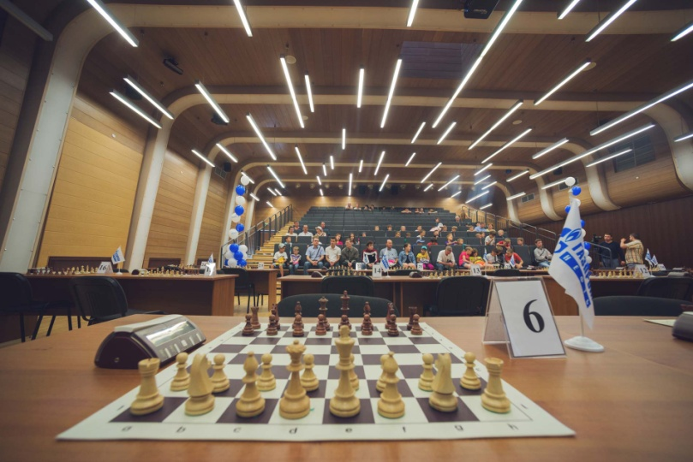

Executive Directorate of the Organizing Committee
of the FIDE World Junior Under-20 Championships 2015
Autonomous Institution of Khanty-Mansiysk autonomous okrug – Ugra
«UgraMegaSport»

Executive Director
Radchenko Valery
Tel: 8 (3467) 358-700
Website: www.ugrasport.com

OC Office
OC Office Chief – Oxana Osintseva
(language skills – German, English)
Tel./Fax: 8 (3467) 36-12-12
E-mail:oc@ugrasport.com

OC Office Specialist – Tatyana Solovar
(language skills – English)
Tel./Fax: 8 (3467) 36-12-12
E-mail: transportation@ugrasport.com

Visa Specialist –Albina Zaynagabdinova
(language skills – English)
Tel./Fax: 8 (3467) 36-14-01
E-mail: visa@ugrasport.com

Accommodation Specialist - Anna Ryadnova
(language skills – English)
Tel./Fax: 8 (3467) 36-14-01
E-mail: accommodation@ugrasport.com

Accreditation Specialist – Alina Safina
(language skills - English)
Tel./Fax: 8 (3467) 36-12-15
E-mail: accreditation@ugrasport.com

Press–officer – Medvedenko Sergey
Tel./Fax: 8 952 722 06 22

Press-attaché – Alexander Parkhomenko
Tel.: 8 (3467) 36-12-34
E-mail: media@ugramerasport.ru
ugrasport.com@gmail.com

Accreditation
The participants of the FIDE World Junior Under-20 Championships 2015 can get accreditation cards in the accreditation center which will work on the 1st of September in the hotel “Olympic” from 10:00 till 16:00.
Accreditation will be made at request in the Ugra Chess Academy (OC Office, ground floor) from the 02th of September 2015.

Access to play area, game-analysis hall and press-center will be carried out due to accreditation cards.
All participants are required to wear their accreditation cards so that they could be easily seen.

Transportation
Transportation operator is located on the ground floor of the Ugra Chess Academy.
Working hours: 14.00 – 21.00
The schedule of shuttle buses will be available on the info stands in the place of accommodation – hotel «Olympic» and at the venue – Ugra Chess Academy.

Transportation for the participants of the Tournament from the hotel to the venue, from the airport to the hotel and back will be organized by the OC free of charge.

Accommodation
The hotel «Olympic» is the official hotel of the FIDE World Junior Under-20 Championships 2015.
Address: 45, Engels St., Khanty-Mansiysk, Tyumen region
Tel.: 8(3467) 31-20-09
Fax: 8(3467) 35-99-37

There is a free internet access (Wi-Fi) at the hotel «Olympic».

Players’ meeting
The player’s meeting of the FIDE World Junior Under-20 Championships 2015 will be held on the day of the Opening Ceremony on the 1st of September in culture and leisure center «October» at 16:00.

All the players of the Championships are required to attend the players’ meeting.

Opening and Closing Ceremonies
The Opening ceremony of the FIDE World Junior Under-20 Championships 2015 will take place on Tuesday, on the 1st of September at 17:00 in the culture and leisure center «October» under the auspices of FIDE. A cultural program with speeches of the officials will be organized.

The Closing ceremony of the FIDE World Junior Under-20 Championships 2015 will take place on Tuesday, on the 15th of September at 19:00 in the culture and leisure center «October». Winners will be awarded with prizes.

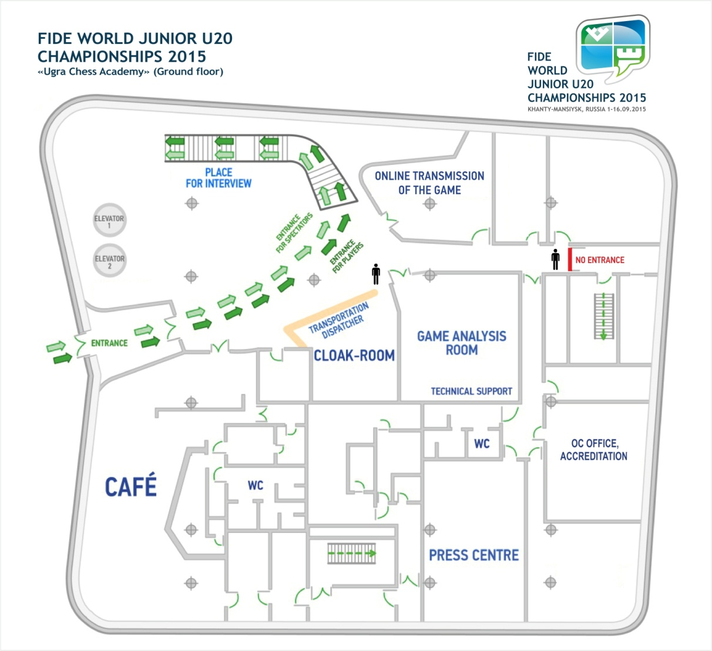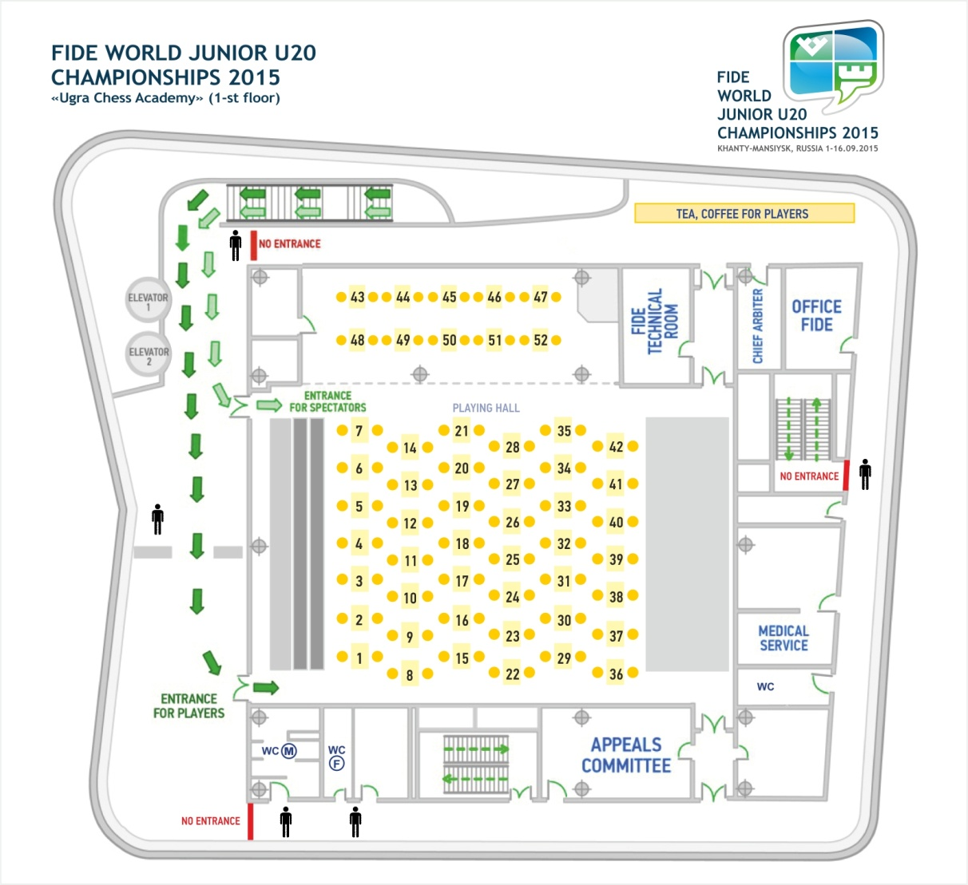

Museums, theatres, galleries, culture and leisure centers

Concert Theatre Center  «Ugra-Classic»  Address: 22, Mira St.  Tel.: 8 (3467) 35-25-35, 35-26-35  www.ugraclassic.ru |  | 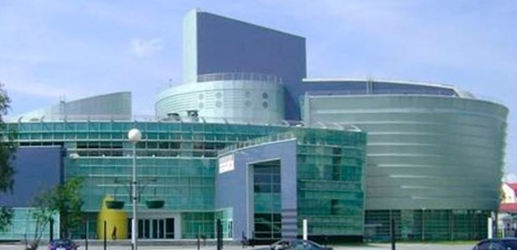
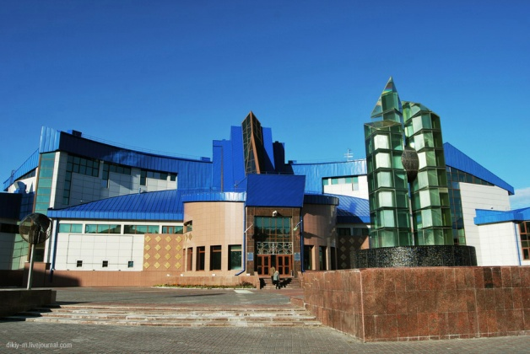 | “Museum of geology, oil and gas”  Open fund storage expositions:  - «Systematic collection of minerals». An Exposition of the crystal-chemical categories of minerals and information on mineralogy;  - «Fanciful world of stones». An items exposition of decorative and applied arts made from semi-precious stones.  Address: 9, Chekhov St.  Tel: 8 (3467) 33-09-42  www.muzgeo.ru
«Human and nature museum»  Stationary exhibition “Connection of times”:  - Historical time;  - Mythological time;  - Biosphere rhythm.  Address: 11, Mira St.  Tel.: 8 (3467) 32-92-03  www.ugramuseum.ru |  | 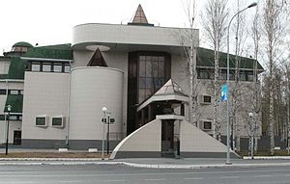
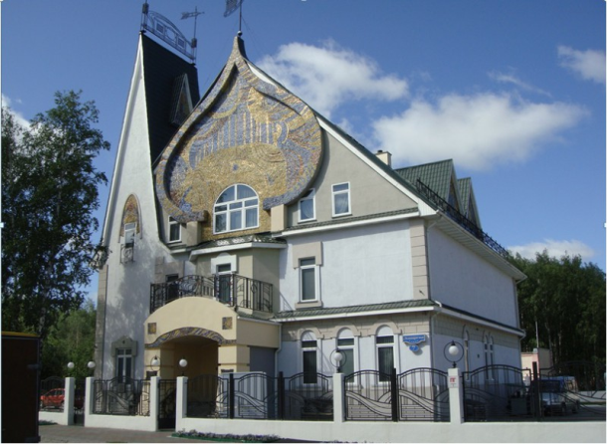 | «House-museum of V. Igoshev – people’s artist of the USSR»  Stationary exhibition:  - «Ugra land by eyes of heart».  Address: 7, Loparev St.  Tel.: 8 (3467) 33-09-45, 33-07-83
«G. Rayshev’s Gallery and  Art Studio»  Stationary exhibition:  - «Space-Time».  Address: 2, Mira St., building «C»  Tel.: 8 (3467) 31-82-84 |  | 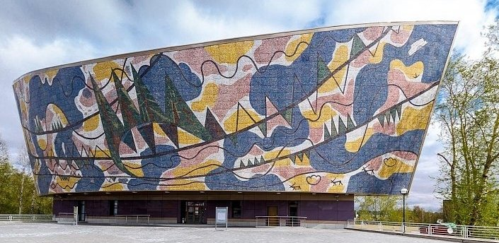
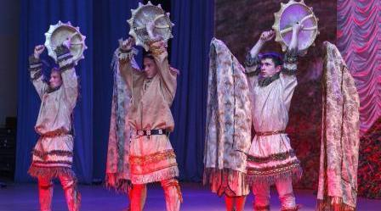 | «Theater of the ob-ugrian people – Solntse»  Address: office 220, 14a, Mira St.  Tel.: 8 (3467) 33-54-61, 33-54-62, 33-54-64  www.toun.ru
«Ethnographic open-air museum Torum Maa»  Stationary exhibitions:  - Summer nomad camp of Agan Khanty;  - Winter Nomad Camp of Mansi;  - Hunting path and Sanctuary.  Address: 2B-2, Mechanizatorov St.  Tel.: 8 (3467) 32-67-06  www.torummaa.ru |  | 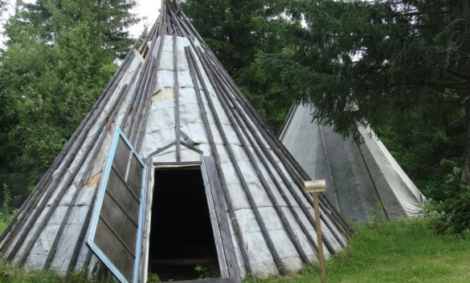
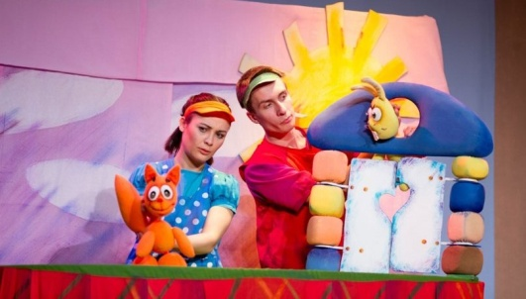 | «Puppet theater»  Address: 15, Dunina-Gorkavicha St.  Tel.: 8 (3467) 32-79-63  www.hmtk.ru
Culture and Tourism center “Samarovskiy ostanets. Archeopark”  Exhibitions of the ice-age animals, story of Samarovskiy ostanets  Address: 29, Obezdnaya St.  Tel.: 8 (3467) 32-12-37  www.ugramuseum.ru |  |  | 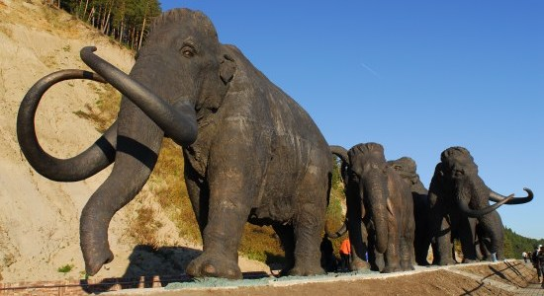
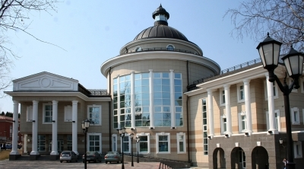 | State Art Museum  Stationary exhibitions:  - The Old Russian art XV-XIX cc.;  - «Women’s images through the centuries»;  - Russian art XVIII-XX cc.  Address: 2, Mira St.  Tel.: 8 (3467) 33-07-83  www.ghm-hmao.ru
Aqua park  Big and small swimming pools, round pool for kids, water slides  Address: 1, Ledovaya St.  Tel.: 8 (3467) 35-84-66  www.ugramegasport.ru |  |  | 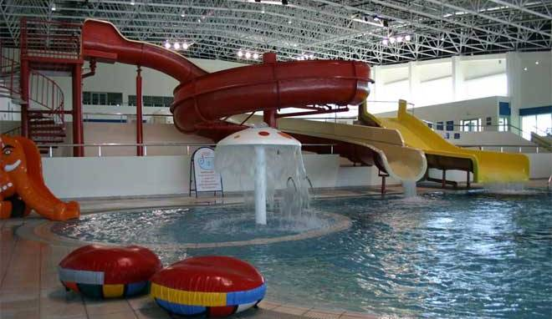

Excursion
The Organizing Committee of Khanty-Mansiysk can organize a sightseeing tour around the city. It is required to make a request at the OC office not less than 24 hours before the excursion, on condition that the group will contain not less than 10-15 people.
Tel.: 8 (3467) 36-14-01
National dishes

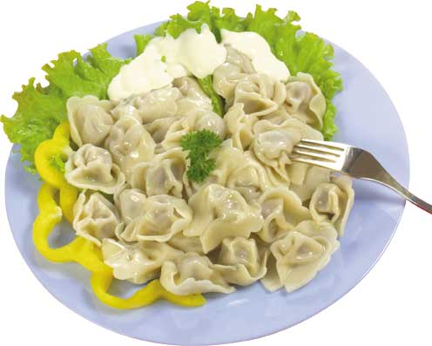 | Pelmeni  Most people associate pelmeni with Siberia. Pelmeni probably did originate in Siberia, where hundreds or even thousands can be made and then frozen and stored outside during the long winters. The dough is rolled out fairly thin and cut in circles. The filling is usually a mixture of minced pork, onions, garlic, salt and pepper.
Russian borscht  Borscht is a multi-component soup.  The main component of any borscht is a beet, it creates the flavor, color and aroma of the borscht. |  | 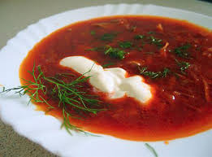
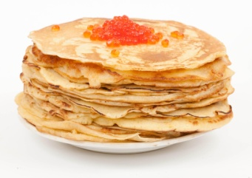 | Bliny (pancakes)  Russian bliny are known as the thinnest ones. Russian pancakes are served with different dressings – most popular are sour cream, jam, red caviar, salmon and others.
Stroganina  Frozen fish (whitefish, sterlet) or meat, one of the main dishes of the northern cuisine. It is served in a raw frozen form. It is cut into chips. For a taste steak is dipped in special sauce – salt mixed with black pepper. |  | 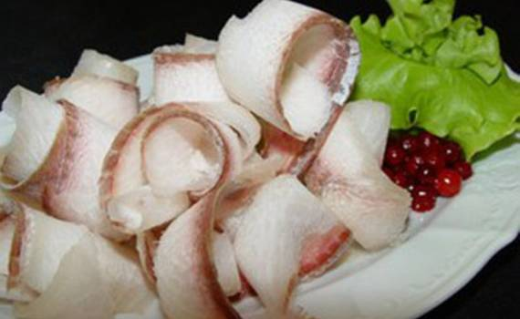
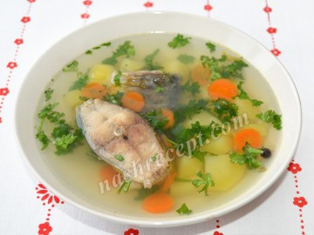 | Uha  Fish broth or soup.
Beef stroganoff  Beef stroganoff is a dish consisting of strips of lean beef sautéed and served in a sour-cream sauce with onions and mushrooms. |  | 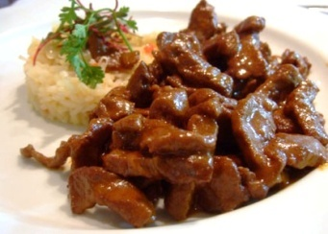
Rasstegay pie with fish
Rasstegai is a kind of pies with a small hole on the top. It is usually filled with fish.

Shashlyk  Shashlyk is generally made of beef, pork or lamb. Meat is marinated overnight in a high acidity marinade like vinegar, dry wine or sour fruit/vegetable juice with addition of herbs and spices. Shashlykis grilled on a grill called«mangal». |  | 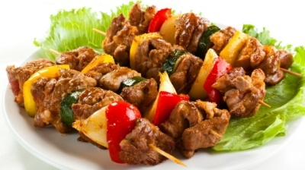

Voltage
Electricity throughout Russia is 220 Volt/50 Hz.

Money
The Russian currency is Russian ruble (RUB). All prices are generally quoted in rubles. Foreign currency can be freely converted at banks.

Frequentlyusedcoins: 10, 50 kopeks, 1,2,5,10 RUB
Rarely 1, 5 kopeks
Frequentlyusedbanknotes: 10, 50, 100, 500, 1000, 5000RUB

Credit cards
International cards such as Maestro, Visa, Visa Electron and Cirrus are easy to acceptin Khanty-Mansiysk. In some places only cash is accepted, for example in taxi, therefore it is recommended always to have some cash.
Tipping
Tipping is expected at restaurants. Tip 10-15 % depending on service.

International calls
How to make International calls from Russia:
Access code country code area code phone number
(810 *** *** *** *** ** **)
International calls to Russia:
Country code area code phone number
(007 *** *** *** ** **)

How to buy an air ticket
West-Siberian Agency of Air Service
Address: 13 Mira St. Tel.: 8 (3467) 33-08-56

UTair airline
Address: 42 Lenin St. Tel.: 8 (3467) 33-33-78

Transportation agency
Address: 28 Komsomolskaya St. Tel.: 8 (3467) 33-08-06, 32-18-76, 32-36-39

Bus station information, ticket booking:
Address: 3 Shcherbiny St., Tel.: 8 (3467) 33-98-30 – booking office

Air and railway ticket offices:
Address: 3 Shcherbiny St., Tel.: 8 (3467) 33-97-90

Address: 5 Mira St., Tel.: 8 (3467) 33-24-45

Khanty-air booking office:
Tel.: 8 (3467) 39-42-93 – the building of the airport

Reference information
Emergency call service
From a stationary phone:
Fire 01
Police 02
Emergency ambulance03
Emergency gas service 04
Information about town phone numbers 09

From a mobile phone:
The number 112 is available for calling the special services both in Russian and English languages.
Emergency call 112 is possible:
- In the absence of money resources on your account;
- In case of blocking of the telephone SIM-card;
- In the absence of the telephone SIM-card.
The call of emergency service is free.

«Disaster Medicine Center»
Address: 4, Sovetskiy lane
Tel.: 8 (3467) 33-83-10, 33-83-11 person on duty (twenty-four hours)

All-night drugstore «Valeo Farm»
Address: 79, Gagarin St. Tel.: 8 (3467) 32-38-59

Twenty-four hours medical aid:

«Okrug Clinical Hospital»
Address: 40, Kalinina St. Tel.: 8 (3467) 39-01-96, 39-02-56 – reception of the hospital (twenty-four hours)
You can receive medical care at the reception of the hotel – you should address to the receptionist (twenty-four hours).

«Okrug Dental Hospital»
Address: 75, Rosnina St.
Tel.: 8 (3467) 35-17-44 – reception (day time)
Tel.: 8 (3467) 35-17-19 – duty doctor (night time)

Taxi
Taxi is available 24 hours. Fare variesfrom100 rubles to 400 rubles.
Phone numbers:
8 (3467) 35-05-05; 32-77-77; 32-33-33; 32-39-99; 33-64-64;
8 (3467) 32-22-22; 35-55-55; 32-11-11; 33-54-54; 33-03-03.

Currency exchange

Near the Ugra Chess Academy

Sberbank
Address: 14, Loparev St. Tel.: 8 (3467) 32-02-58
16, Dzerzhinsky St. 8 (3467) 36-36-05
Zapsibkombank
Address: 11, Sverdlov St. Tel.: 8 (3467) 33-46-01
8 (3467) 33-16-77
Bank «Poidem!»
Address: 27a, Chekhov St. Tel.: 8 (3467) 32-97-45

Surgutneftegasbank
Address: 41, Mira St. Tel.: 8 (3467) 33-02-98

Near the hotel «Olympic»

Bank«Poidem!»
Address: 27, Engels Street Tel.: 8 (3467) 32-97-44

Bank of Khanty-Mansiysk
Address: 39, Lenin St. Tel.: 8 (3467) 32-31-85
3, Engels St. 8 (3467) 35-08-89

Other currency exchange offices

Bank of Khanty-Mansiysk
Address: 68, Mira St. Tel.: 8 (3467) 33-01-00
8 (3467) 32-58-67
Sberbank
Address: 10, Obyezdnaya St. Tel.: 8 (3467) 36-40-25
31, Komsomolskaya St. 8 (3467) 35-96-75

Souvenirs
The center of the people’s arts and crafts Address: 119 Rosnin St. Tel.: 8 (3467) 33-23-96
The retail and business center «Gostinydvor» Address: 1 Engels St.
The entertainment center «Langal» Address: 15 Mira St.
«Ugra» hotel Address: 32 Komsomolskaya St.
«UgorskayaDolina» hotel Address: 4 Tobolskiytract.
«Taray» hotel Address: 64 Lenin St.
«On seven hills» hotel complex Address: 15 Sportivnaya St.

Cafes

Name | Address | Phone
Café «Subway» | 25 Kalinin St. | 8 902 856 49 34
Bar «Uyutnoe nebo», entertainment center «Langal» | 15 Mira St. | 8 (3467) 33-58-89
Cafe «French Cafe» | 6, Loparev St. | 8 (3467) 30-66-00
Restaurant «Liberty» | 31, Komsomolskaya St. | 8 (3467) 32-44-88
Cafe-confectionary «Lakomka» of the hotel «On seven hills» | 24 SportivnayaSt. | 8 (3467) 35-52-64
Fast food cafe «Chiki-briki», «Gostiny dvor» | 1 Engels St. | 8 (3467) 31-01-61
Sushi-bar «Ya za sushi» | 45A Shevchenko St.  26 Engels St. | 8 (3467) 32-93-48  8 (3467) 32-94-82
Cafe «Sladkoezhka» | 32 Komsomolskaya St. | 8 (3467) 39-55-53

Food delivery

«Pizza Hans» | 8 (3467) 30-88-03,  8 (3467) 90-90-90 | Pizza, pasta, sushi, rolled sushi, noodle
«Rendez-vous» | 8 (3467) 33-29-54 | Japanese cuisine
«Senior Tomato» | 8 (3467) 32-04-04,  8 (3467) 33-52-59 | Pizza, salads, drinks
«Sytii San» | 8 (3467) 92-22-99,  8 (952) 722-22-99 | Японская кухня и итальянская пицца
«Assorty» | 8 (3467) 32-28-06 | Pizza, European and Russian cuisine
«Ya za sushi» | 8 (3467) 32-93-48,  8 (3467) 36-78-80 | Sushi, rolled sushi, pizza, hot dishes, salads
«Poseidon» | 8 (3467) 30-76-00,  8 (3467) 33-82-62 | European and Japanese cuisine
«Dzhuzeppe» | 8 (3467) 33-62-00 | Pizza, hot dishes
«Doka» | 8 (3467) 34-11-41 | Pizza
Delivery service «Gorod» | 8 (3467) 36-74-32,  8 (3467) 36-74-49 | Japanese and Chinese cuisine, pizza, salads
«Chiki-briki» | 8 (3467) 31-01-51,  8 (3467) 31-01-61 | Hot dishes

English–Russian conversation book

Hello! | Zdrávstvuyte!
Hi! | Privét!
Good morning! | Dóbroye útro!
How can I get to …? | Kak proytí v ….?
Thank you | Spasíbo
How are you? | Kak delá?
I’m fine | U menyá vs’o khoroshó / Vs’o khoroshó
How much is …? (about prices) | Skól’ko stóit …?
Excuse me … | Izviníte …
Sorry | Prostíte
Glad to see you! | Rad vas vídet’!
My phone number is … | Moi nómer telephóna …
Call me | Pozvoníte mne
What is your name? | Kak vas zovút?
My name is … | Menyá zovút …
Pleased to meet you | Rád poznakómit’sya
Where (when) can we meet? | Gd’e (kogdá) my vstrétimsya?
May I offer you a cup of coffee? | Mogú ya vam predlozhít’ cháshku kófe?
You are mistaken | Vy oshibáyetes’
I don’t think so | yatak ne dúmayu
It’s impossible | Éto ne vozmózhno
Do you speak English? | Vy govoríte po anglíyski?
I don’t understand you | Ya vas ne ponimáju
Repeat, please | Povtoríte, pozháluysta
What does this word mean? | Shto znáchit éto slóvo?
Where can I have dinner here? | Gd’ezdes’ mózhno poobédat’?
Can I have the menu, please? | Dáit’e mne, pozháluysta, menyú
Bring me the bill, please | Dáit’e mne, pozháluysta, stschyot
Where is … here? | Gd’e zdyes’ …?
I want to exchange money | Mn’e núzhno obmenyát’ dén’gi
Good bye! | Do svidánya!
Bye! | Poká!
Good luck! | Udáchi!
I hope we’ll meet again | Nadéyus’ my yetschyo vstrétimsya

